*The usual “I have no idea what I’m doing” disclaimer… Solutions are probably mistake riddled, pls delete images and replace with real solutions as you see fit <3 Also I didn’t get round to doing Q4 yet.*

Answer to 1ai) and ii) could be found on Tutorial Sheet 4 question 5 (as of 2020-21)

;

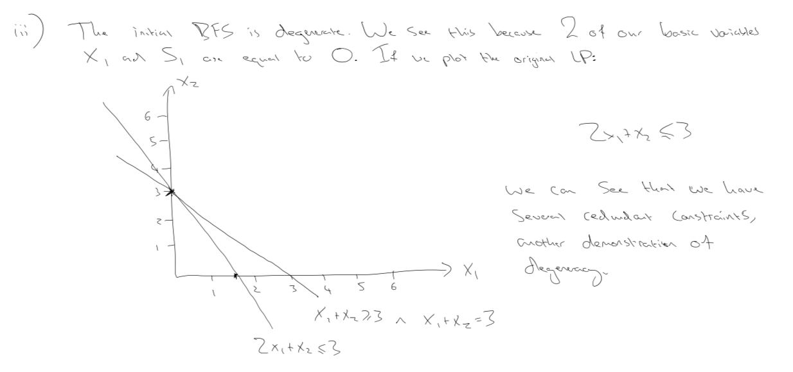

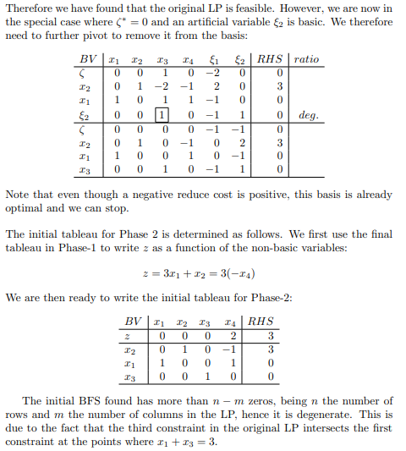

1b.

i) The standard simplex algorithm (given that there are no degenerate basic feasible solutions, which is avoided through Bland’s Rule) there are n variables and m constraints. Hence there are nCm basis combinations / Index sets. Due to the strictly decreasing nature of the simplex algorithm this then provides the upper bound.

Ii ) (2019: This solution doesn’t talk about the KM Cube, as we didn’t cover that, but it the reverse of the degeneracy argument in the slides)

Assume there was no finite termination for the simplex algorithm. As there are no degenerate basic feasible solutions, each iteration must be strictly decreasing as $β'_{0}=β_{0}-\frac{β_{q}}{y_{pq}}y_{p0}$ and as not degenerate, the subtraction term must be positive and non-zero.

This implies that there is a different basis/index set being used (as the same index set or previously used basis would have a higher $β_{0}$). As we’ve seen in part i), the number of index sets is finite, and hence we cannot have an infinitely strictly decreasing $β_{0}$ and so the assumption is incorrect.

Wasn’t sure how to do 1B… The proof to 1bii) is in the notes I believe?

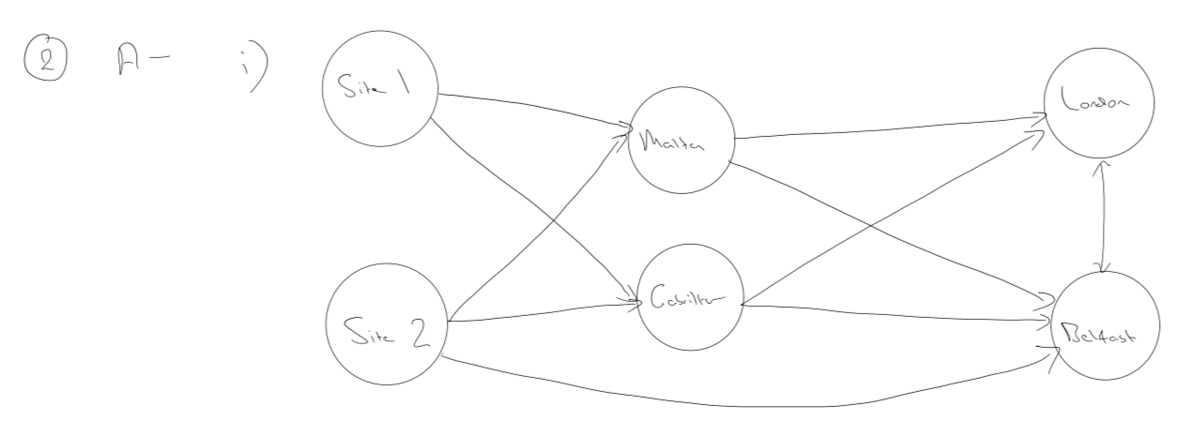

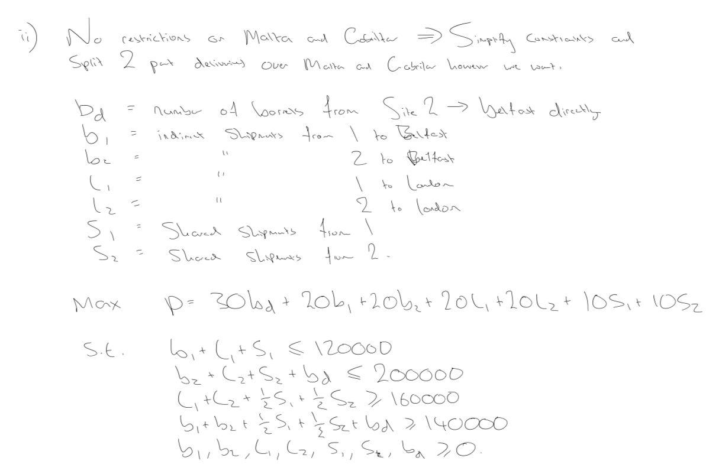

222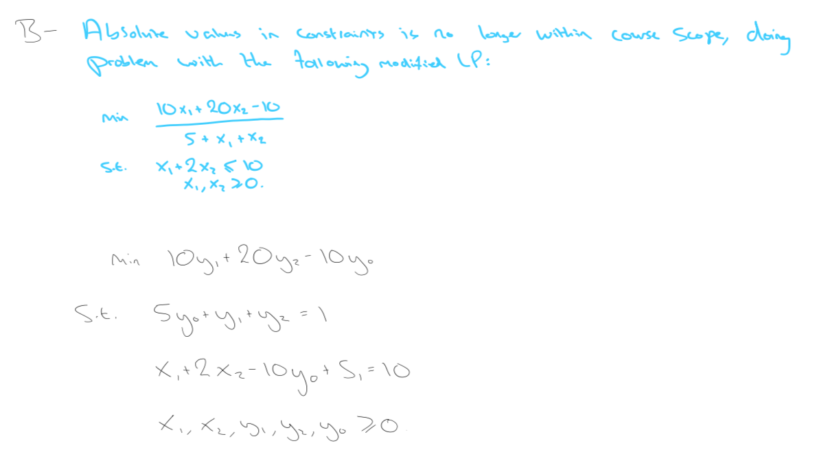

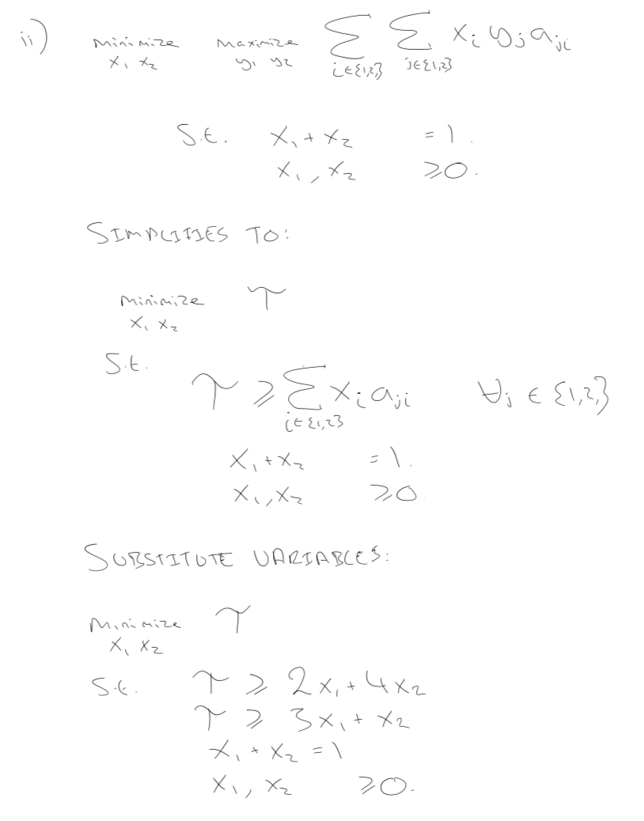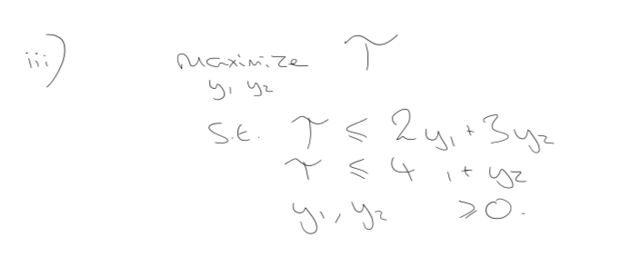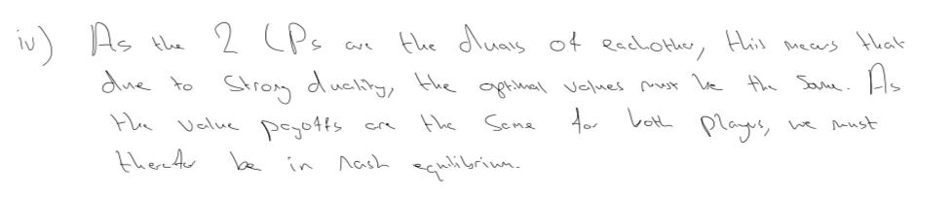 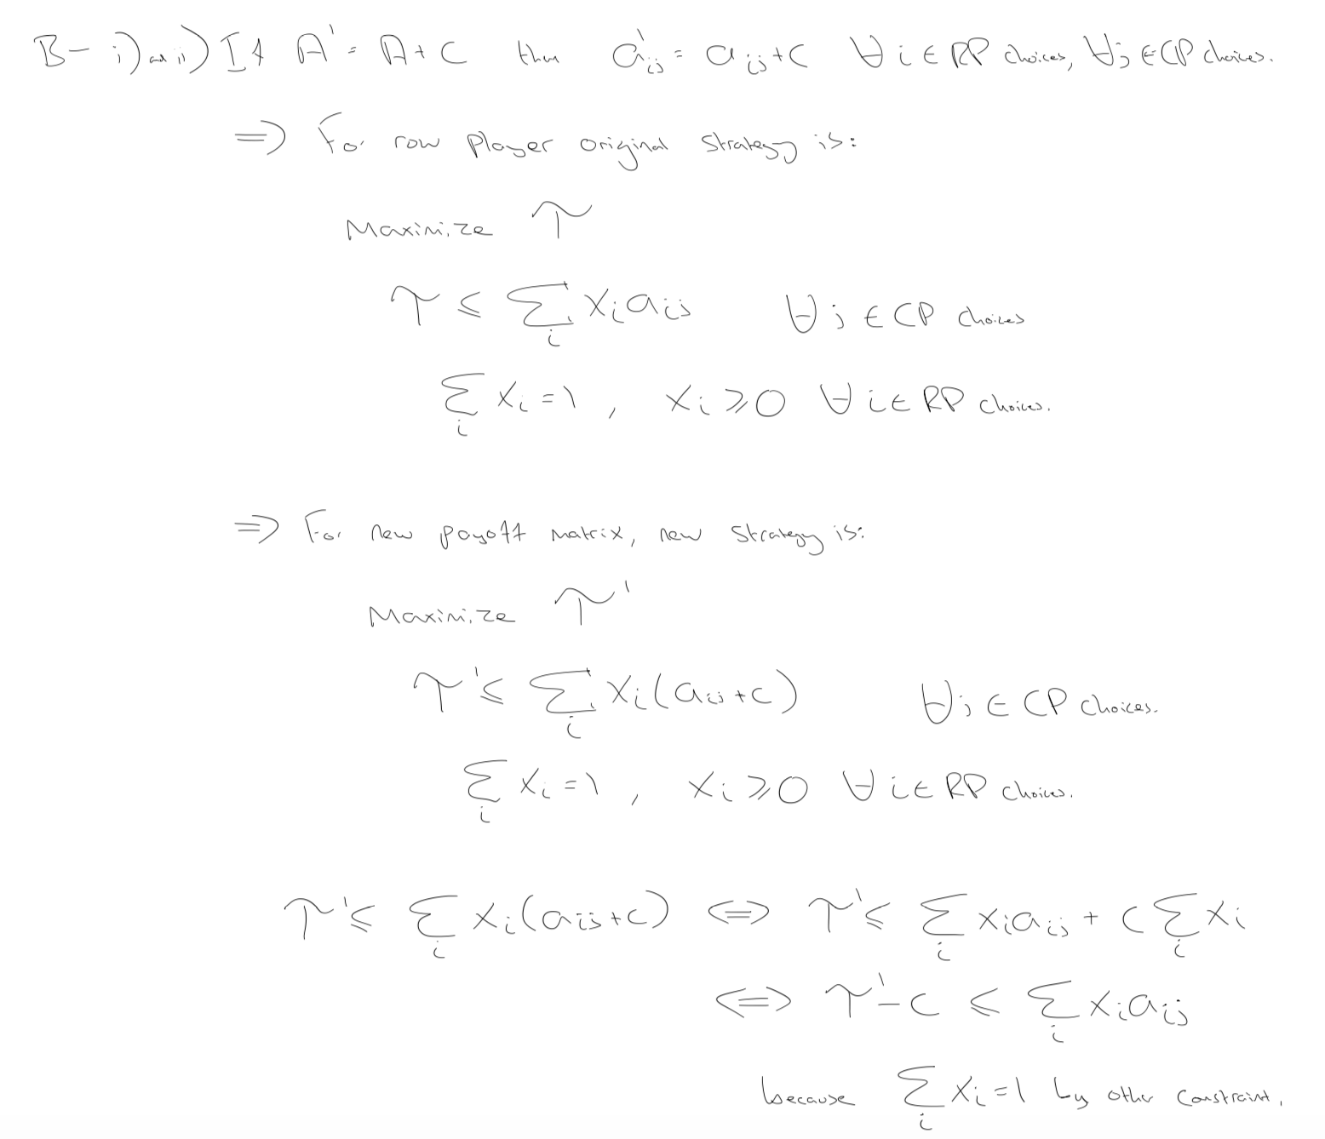 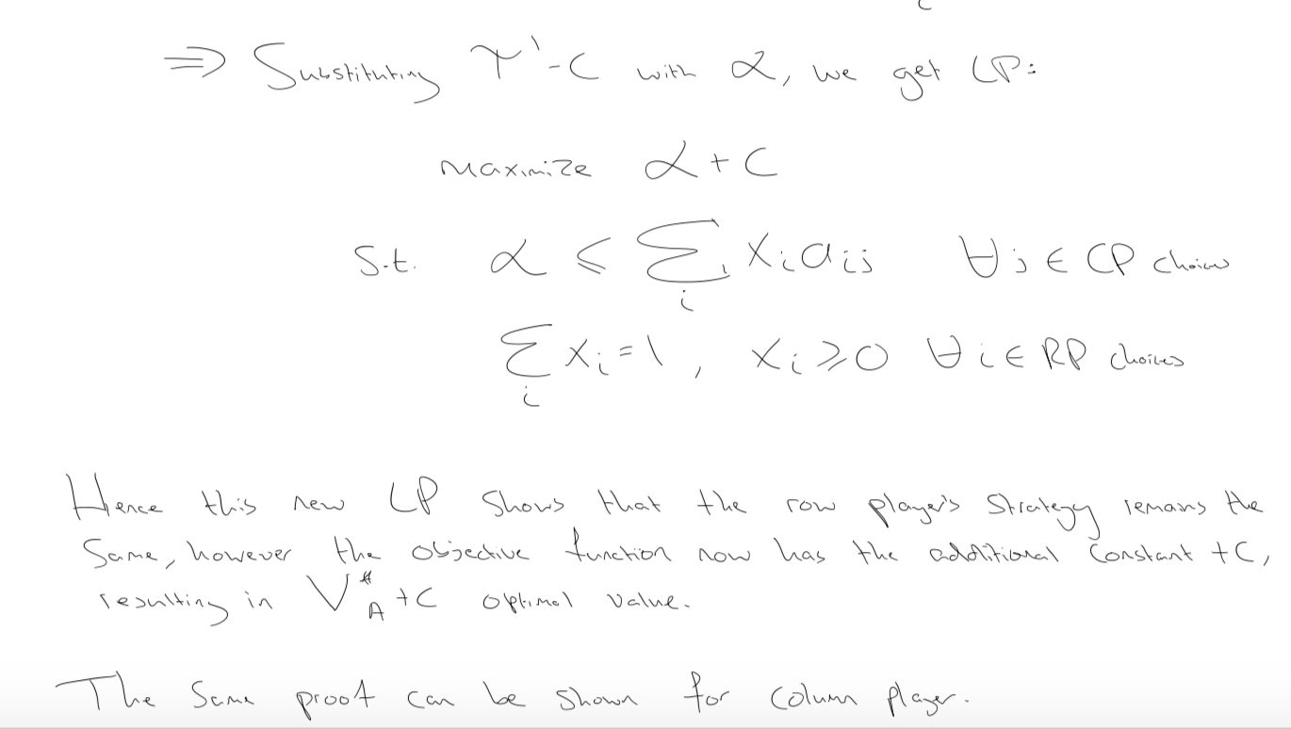

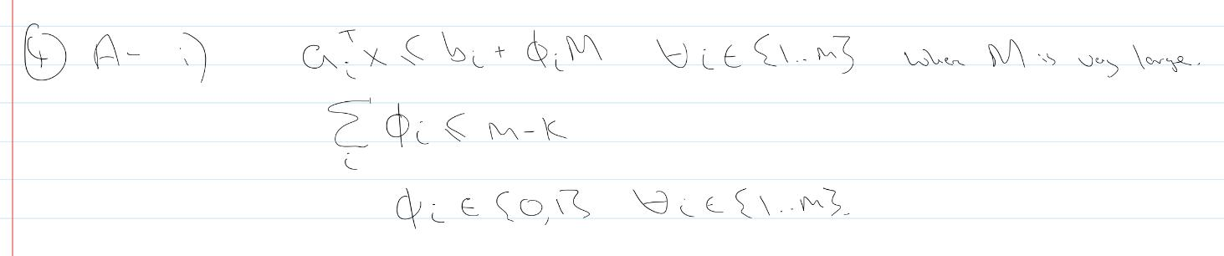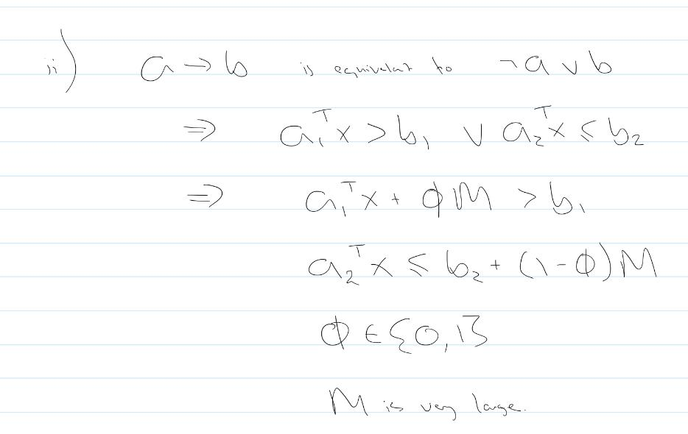

L’\

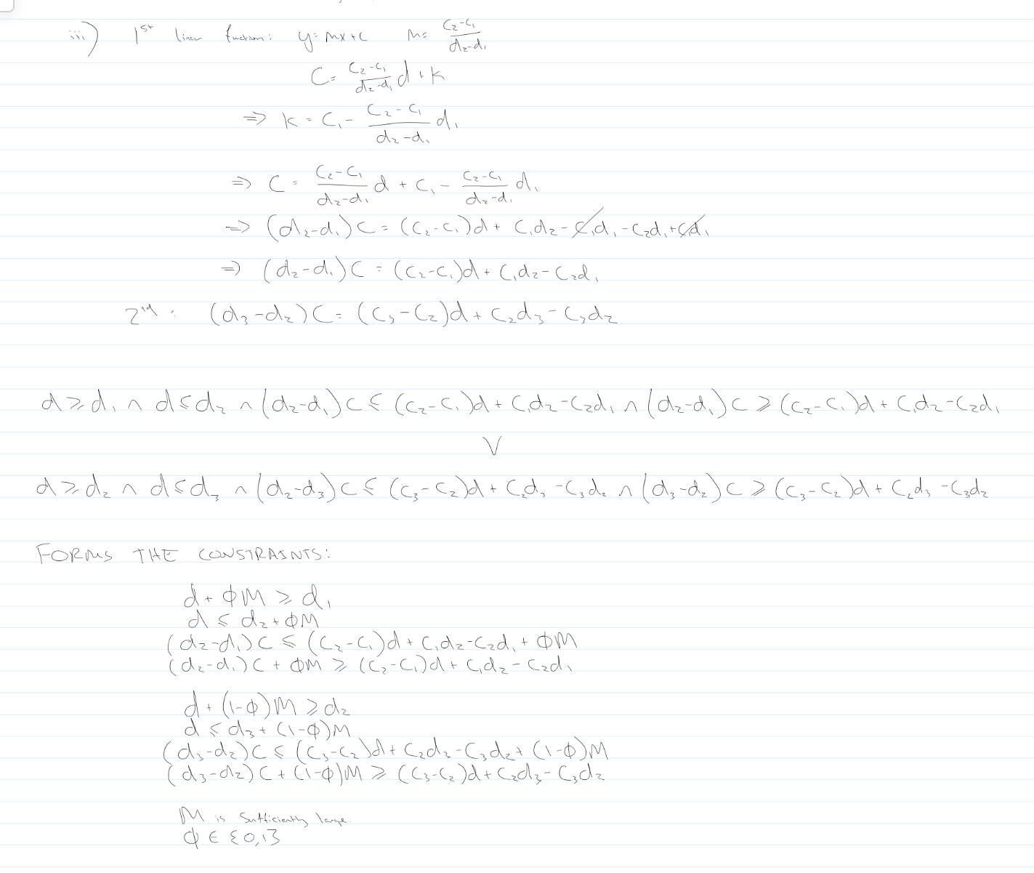

4b) P1: add constraint x1 <= floor(1.5) = 1. P2: add constraint x1 >= ceiling(1.5) = 2.

P1: x0 = -8, x2 = 2, s2 = 2, s3 = 10, x1 = 1. Do not need to search subproblems of P1 as x1, x2, s1 and s2 are all integers.

P2: x0\* = -9, x1 = 1.5, x2 = 2.5, s3= 8, s4 = ½.

P2: x0\* = -6, x1 = 2, x2 = 7/3, x3 = 2/3, x5 = 20/3. Stops the algorithm since –6 > -8 = cTx\*(P1).

We therefore consider P3 and P4: P3 has additional constraint x2 <= floor(2.5) = 2 and P4 has constraint x2 >= ceiling(2.5) = 3. Note that P4 must be infeasible as x1 >= 2 and x2 >= 3 means x1 + 3x2 > 9 for all x1 and x2 in our range, and so we say P4 is infeasible.

P3: x0 = -4, x2 = 2, x1 = 2, s1 = 1, s2 = 1, s3 = 7, s4 = 0. All are integers and so there is no further optimal solution => x0\* = -8 (with x2 = 2, x1 = 1, s2 = 2, s3 = 10 - same as both P1).